RESOLUTION NO.__________

RE: CERTIFICATE OF APPROPRIATENESS UNDER THE
PROVISIONS OF THE ACT OF THE PENNSYLVANIA
LEGISLATURE 1961, JUNE 13, P.L. 282 (53
SECTION 8004) AND BETHLEHEM ORDINANCE NO.
3952 AS AMENDED.

WHEREAS, it is proposed to change the existing sign on the front of the building and add window signage at 530 E. 4th St.

NOW, THEREFORE, BE IT RESOLVED by the Council of the City of Bethlehem that a Certificate of Appropriateness is hereby granted for the work.

Sponsored by: (s)

(s)

ADOPTED BY COUNCIL THIS DAY OF

(s)
President of Council

ATTEST:

(s)
City Clerk

HISTORIC CONSERVATION COMMISSION

CASE # 443 – It is proposed to change the existing sign on the front of the building and add window signage at 530 E. 4th St.
OWNER/APPLICANT: Padro and Lucy Ramos / Donald Smith

The Commission upon motion by Mr. Cornish seconded by Mr. Evans adopted the proposal that City Council issue a Certificate of Appropriateness for the proposed work described herein:

- The proposal to change the existing sign on the front of the building and add window signage at 530 E. 4th St. was presented by Donald Smith.

- The new sign in the transom mounted box will read “Forever Ink Tattoo Studio” in yellow lettering with a background texture to match the business card.

- Two gooseneck lights will be mounted to the top of the box to illuminate the sign.

- Vinyl signage will be added to the front window. At the top of the window will be “Custom Tattoos” in an arc. At the bottom of the window will be the hours in one corner and the telephone number in the other corner.

- A scaled drawing of the final layout of the window signage must be submitted to the City and approved by the Historic Officer.

- There will be no sign on the door.

- The proposed motion was unanimously approved.

CU: cu

By: 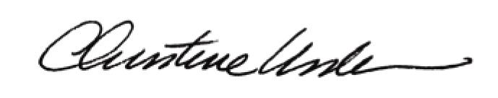

Date of Meeting: February 25, 2013 Title: Historic Officer

